# Assignment -3

Python Programming

|  |  |
| --- | --- |
| Assignment Date | 14-10-2022 |
| Student Name | JASWANTH G |
| Student Roll Number | 111619106050 |
|  |  |

# Question-1:

Write a python code for blinking LED and Traffic lights for Raspberry Pi.

# Solution:

from gpiozero import Button, TrafficLights, Buzzer from time import sleep

buzzer=Buzzer(15) button=Button(21) lights=TrafficLights(25,8,7)

while True:

button.wait_for_press() buzzer.on() light.red.on()

sleep(1) lights.amber.on() sleep(1) lights.green.on() sleep(1) lights.off() buzzer.off()

# Output:

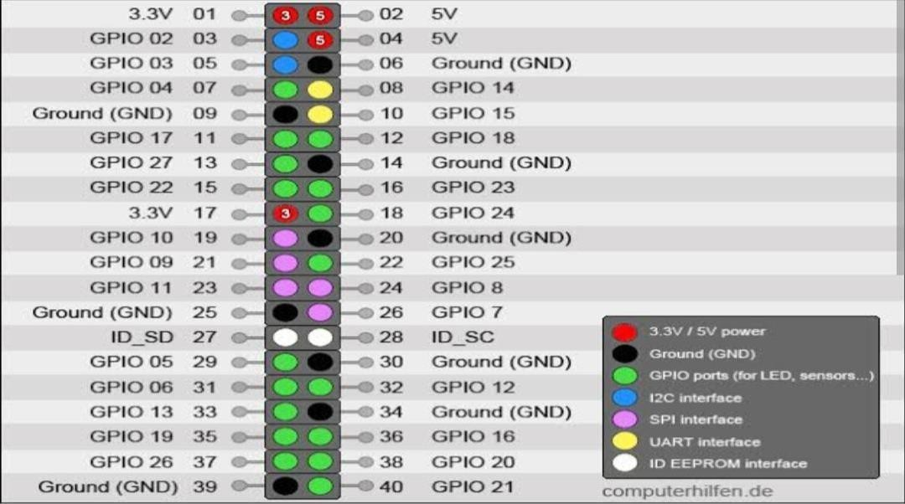

**GPIO PINS USED:**

* GP 21-BUTTON
* GP 15-BUZZER
* GP 25- RED LED
* GP 8- YELLOW LED
* GP 7- GREEN LED